Networking Commands

1. ping google.com | head -> The ping google.com command sends ICMP echo requests to Google's server to check network connectivity and measure response time. It helps diagnose internet connection issues and network latency.

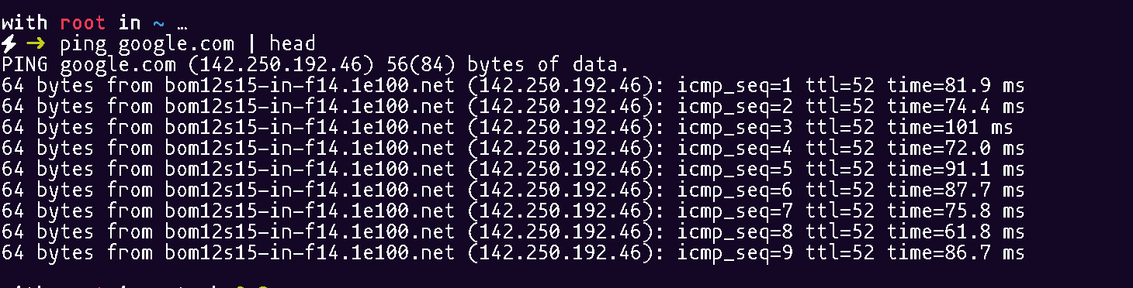

1. ip address -> The ip address command (or ip addr) displays information about the system's network interfaces, including assigned IP addresses. It is used to check and configure network settings.

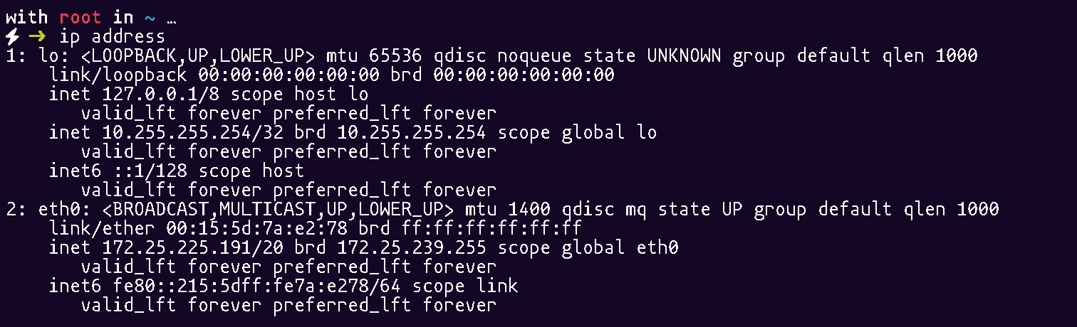

1. traceroute google.com | head -> The traceroute google.com command shows the path packets take to reach Google's server, listing all intermediate hops. It helps diagnose network routing issues and latency at different points.

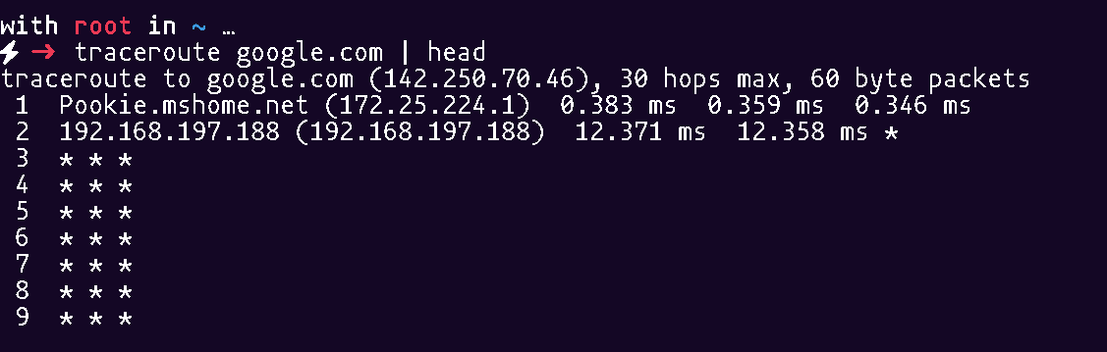

1. mtr google.com -> The mtr command (My Traceroute) combines ping and traceroute, providing real-time network diagnostics. It continuously tracks packet loss and latency across each hop to the destination.

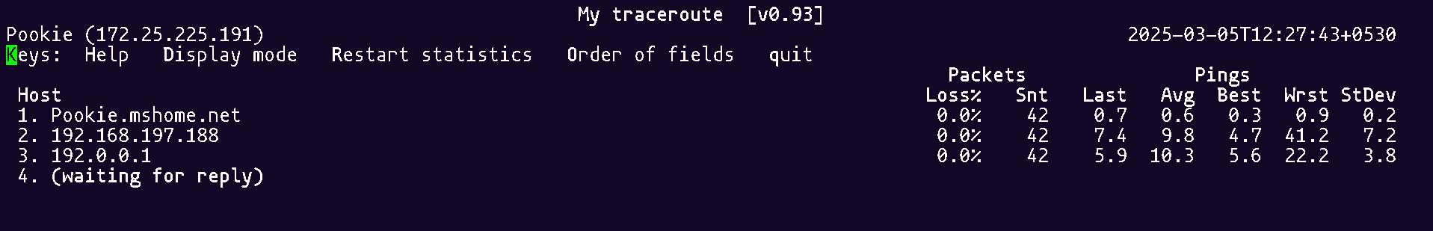

1. ufw status -> The ufw (Uncomplicated Firewall) command is a user-friendly interface for managing firewall rules in Linux. It allows users to enable, disable, and configure firewall settings easily.

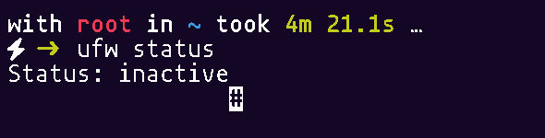

1. curl -I google.com -> The curl command is used to transfer data from or to a server using various protocols like HTTP, HTTPS, and FTP. It is commonly used for API requests, downloading files, and testing network connections. 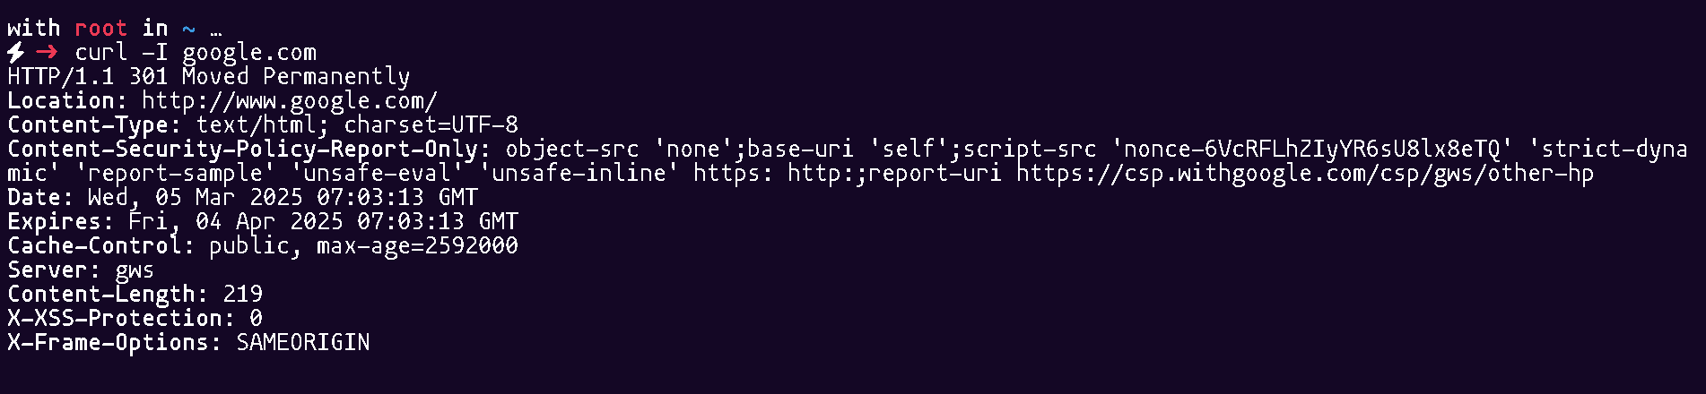
2. wget google.com -> The wget command is used to download files from the web using HTTP, HTTPS, and FTP protocols. It supports background downloading, resuming interrupted downloads, and mirroring websites.

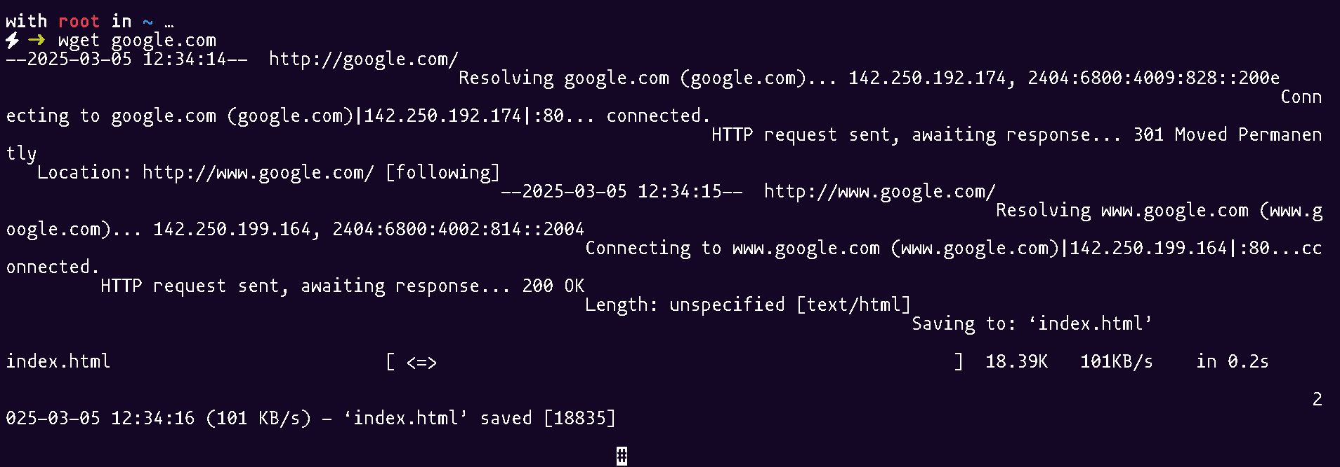

1. tcpdump -i eth0 -> The tcpdump command is a packet analyzer that captures and displays network traffic in real-time. It helps diagnose network issues by filtering and analyzing packets based on various criteria.

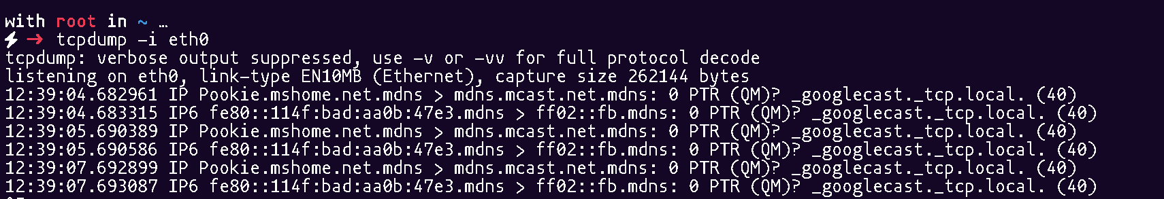

1. hostname -> The hostname command displays or sets the system’s hostname. It is useful for identifying the machine on a network or changing its network name.

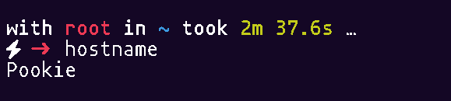

1. resolvectl status -> The resolvectl command is used to query and manage DNS resolution settings on Linux systems using systemd-resolved. It helps check domain resolution, set DNS servers, and troubleshoot network issues.

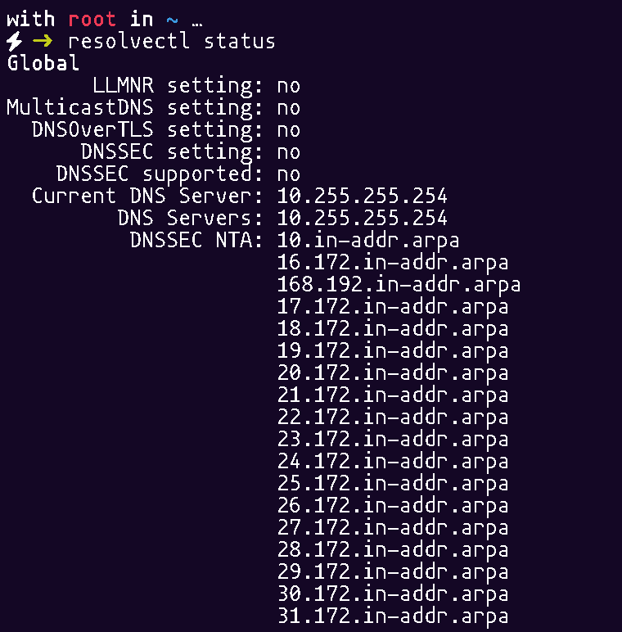

1. dig google.com -> The dig (Domain Information Groper) command is used to query DNS servers for domain-related information, such as IP addresses and mail servers. It helps troubleshoot DNS resolution issues and analyze domain records.

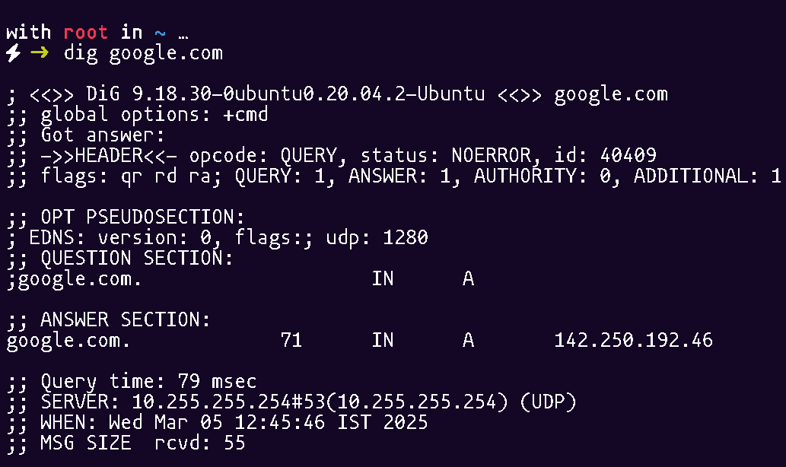

1. nsloopup google.com -> The nslookup command queries DNS servers to obtain domain name or IP address information. It is useful for diagnosing DNS resolution issues and verifying domain records.

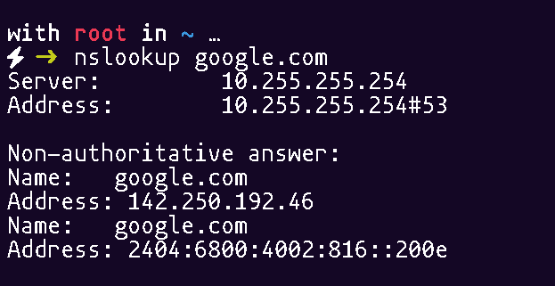

1. ip route show -> The ip route command displays or manipulates the system’s routing table, showing how network traffic is directed. It helps configure and troubleshoot network routes.

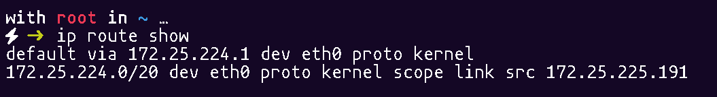

1. ethtool eth0 -> The ethtool command is used to display and modify network interface settings on Linux. It helps check link status, speed, duplex mode, and configure advanced network features.

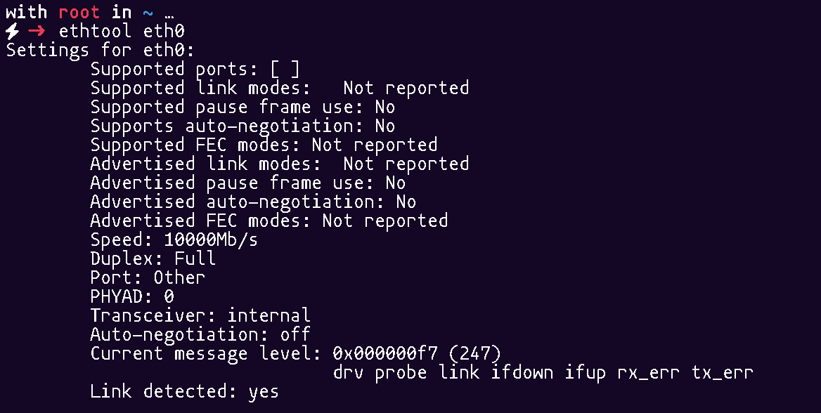

1. nload -> The nload command is a real-time network bandwidth monitoring tool that displays incoming and outgoing traffic. It helps analyze network usage with a graphical representation of data transfer rates.

